To check the Git status:

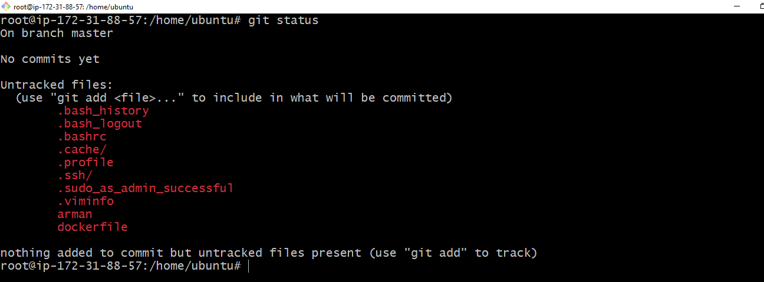

To initialize Git

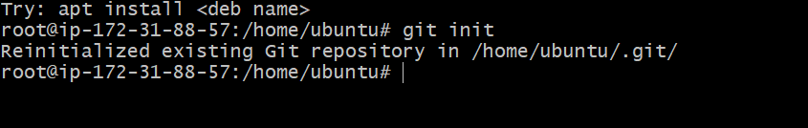

To check what is in .git

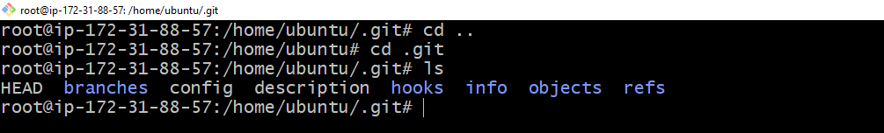

To check the complete detail

Git config --list

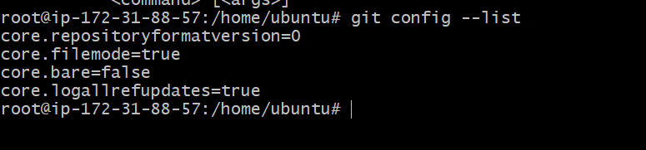

Git config command to add user name



Git config to add mail id



Git add command

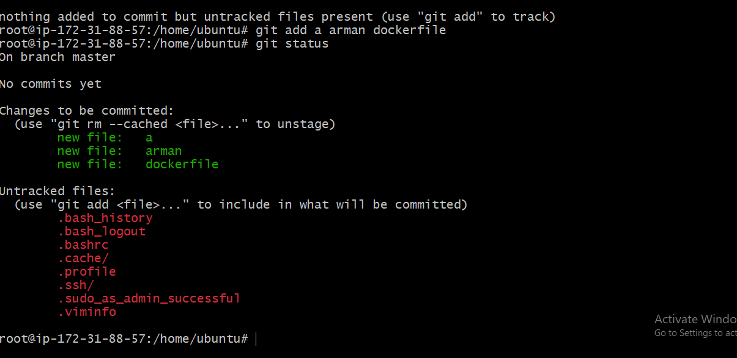

To add all the fie git add .

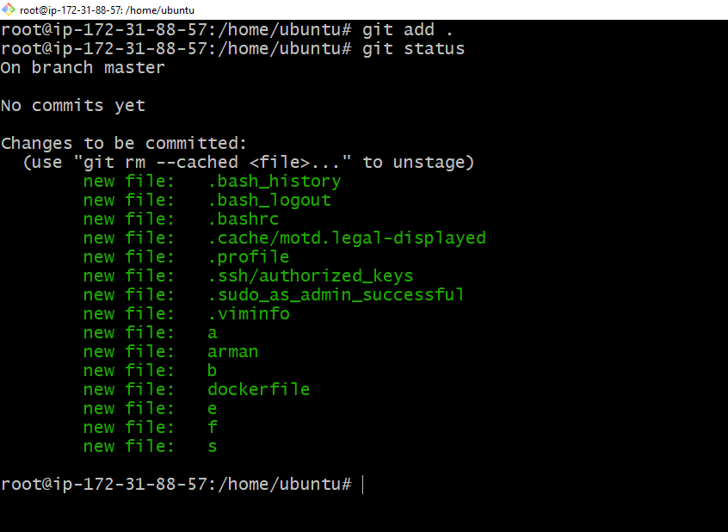

Git Commit command

